REPORT ON SNAKE GAME IN C
Gaurav Jadhav (25FC568)
Yash Khawale(25FC567)

1. AIM
To develop a simple Snake Game using the C programming language that demonstrates basic game logic, array manipulation, keyboard input handling, and console-based animation.

2. OBJECTIVES
- To create a 10×10 game board using a 2D array.
- To implement a movable snake represented by coordinate arrays.
- To generate food at random positions on the board.
- To update the snake’s position based on user input (W, A, S, D).
- To detect collisions with walls and display game-over messages.
- To visualize the game state on the console in real-time
.

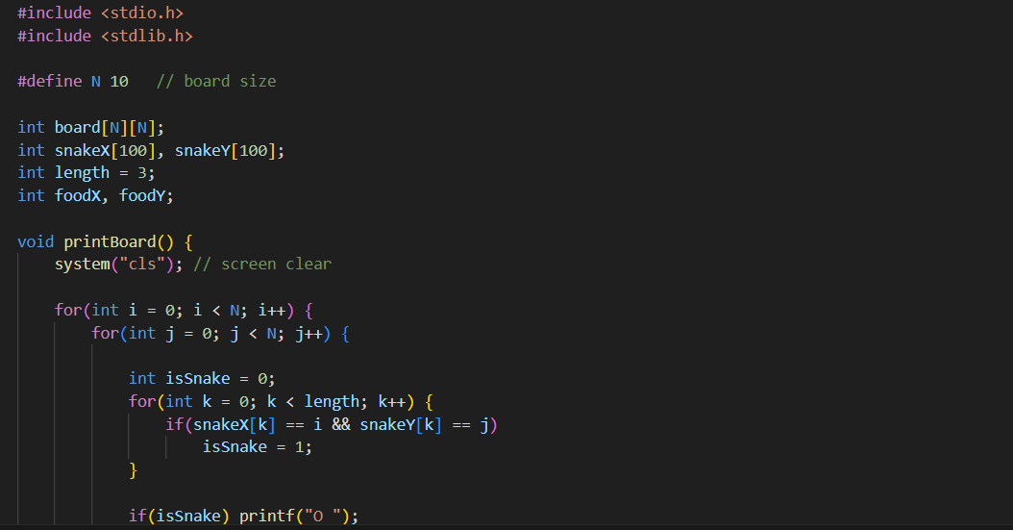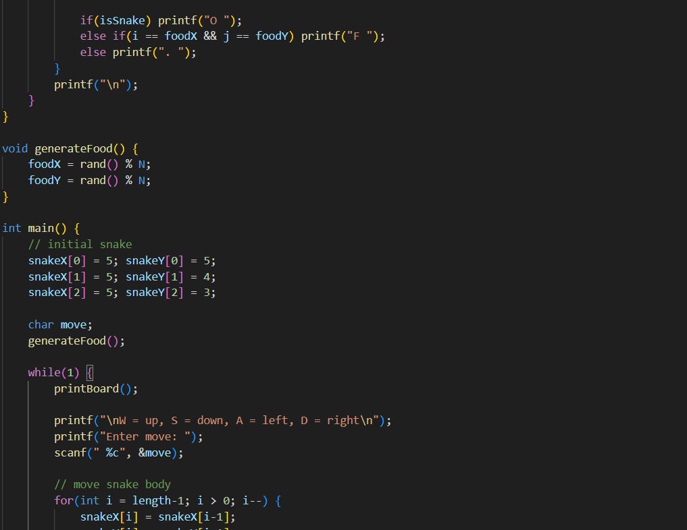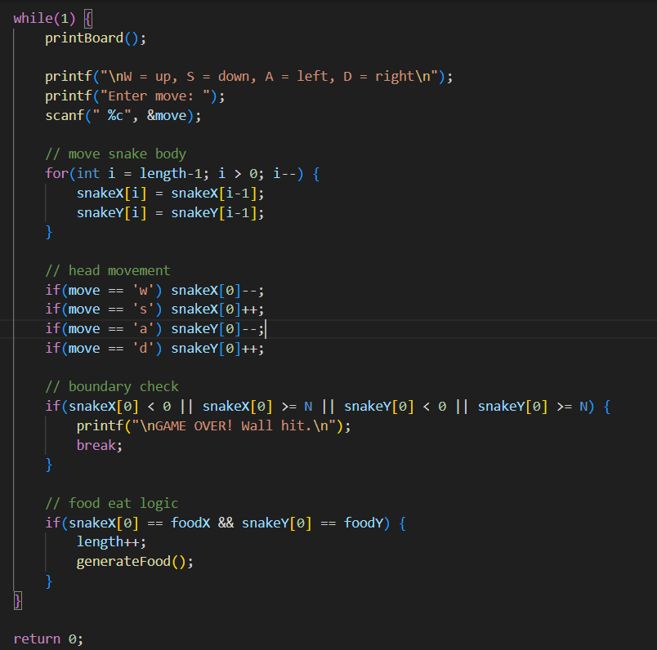

THEORY

3.1 Arrays
Arrays are used to store the positions of the snake’s body:
- snakeX[] stores X-coordinates
- snakeY[] stores Y-coordinates
The board is defined using a 2D array board[N][N].

3.2 Random Number Generation
rand() % N is used to randomly generate food coordinates inside the board.

3.3 Console Manipulation
system("cls") is used to clear the console screen on every frame so that the game appears animated.

3.4 Snake Movement Logic
Snake movement is done by:
- Shifting the body positions backward
- Changing the head position according to key input
Example:
for(int i = length-1; i > 0; i--) {
snakeX[i] = snakeX[i-1];
snakeY[i] = snakeY[i-1];
}

3.5 Collision Detection
The program checks if the snake touches the boundary:
if(snakeX[0] < 0 || snakeX[0] >= N || snakeY[0] < 0 || snakeY[0] >= N)
If true → Game Over

3.6 Food Eating Logic
If head coordinates match food coordinates, the snake grows:
if(snakeX[0] == foodX && snakeY[0] == foodY) {
length++;
generateFood();
}

4. EXPLANATION OF THE CODE

4.1 Board Display Function
printBoard() displays the snake, food, and empty spaces using:
- O for snake body
- F for food
- . for empty cell

4.2 Initial Snake Setup
The first three segments are placed in a horizontal line:
(5,5), (5,4), (5,3)

4.3 User Input
User enters:
- W → Up
- S → Down
- A → Left
- D → Right
scanf(" %c", &move); captures input.

4.4 Snake Movement
The tail follows the head by shifting positions.
The head changes based on user direction.

4.5 Food Generation
generateFood() places food randomly in the board each time the snake eats it.

4.6 Game Over Condition
If snake hits the wall boundary, the program prints:
GAME OVER! Wall hit.
and stops execution.

5. CONCLUSION
The Snake Game program successfully demonstrates key programming concepts in C, including arrays, loops, functions, random number generation, and real-time console updates. The game implements basic snake movement, food generation, boundary collision, and board visualization. It provides an excellent foundation for further improvements such as self-collision detection, smoother animation, scoring, and non-blocking input.

